**UNIVERSITI KUALA LUMPUR**

**MALAYSIAN INSTITUTE OF INFORMATION TECHNOLOGY**

**I-WORKING SPACE WITH ELECTRICAL APPLIANCES CONTROLLER**

**FINAL YEAR PROJECT 1**

**RESEARCH PROPOSAL**

**MODULE: IDB 30102 RESEARCH METHODOLOGY**

**PREPARED BY: ANUAR BIN ROZMAN (52221119269)**

**PREPARED FOR: DR ADIDAH BINTI LAJIS**

**SUPERVISED BY: SAYED AZIZ BIN SAYED HUSSIN, TS.**

**JAN 2022**

**DECLARATION**

I hereby declare that I carried out the work reported in this report in the Computer Engineering Section, Malaysian Institute of Information Technology, Universiti Kuala Lumpur under the supervision of **Ts. Sayed Aziz Bin Sayed Hussin**. I honestly affirm that, to the best of my knowledge, no portion of this report has ever been presented in a previous application for a degree award here or elsewhere. All sources of information used have been properly credited.

……………………………..

ANUAR BIN ROZMAN

52221119269

**APPROVAL**

We have supervised and examined this report and verified that it meets the program and

University's requirements for the Bachelor of Computer Engineering Technology (Computer Systems) with Honours.

|  |  |  |  |
| --- | --- | --- | --- |
| Date: |  | Signature: | …………………………………... |
|  |  | Supervisor: | Ts. Sayed Aziz Bin Sayed Hussin |
|  |  | Official Stamp: |  |
|  |  |  |  |
| Date: |  | Signature: | …………………………………... |
|  |  | Assessor: |  |
|  |  | Official Stamp: |  |

**DEDICATION**

My final project will be dedicated to my wonderful mother, Ipah Binti Abd Rahman, who has been an inspiration to me and has given me strength when I was on the verge of giving up, and who continues to support me morally, emotionally, and financially.

Keep in mind to thank my supervisor, Ts. Sayed Aziz Bin Sayed Hussin, and co-supervisor, Dr. Adidah Lajis, for their help and support in putting this research together. I also dedicated this final year project to all of my lecturers and friends who helped me accomplish it by educating me and correcting my mistakes.

**ACKNOWLEDGEMENT**

Bismillahirahmanirrahim, praise to Allah S.W.T that had been given to me, health, and ideas during the completion of this research. Without Him, I could not stay patient in writing this project from the first page to the last page. I would like to express my special thanks to my supervisor, Ts. Sayed Aziz Bin Sayed Hussin and co-supervisor, Dr. Adidah Lajis who always patient with me. Thank you for always having time to check my project progress and project proposal. I am deeply indebted to him for everything that he does to help me complete this research. A special thanks to my coordinator, Mr Sallehin Bin Mohd Kassim for helping me directly or indirectly in completing this research.

My heartfelt thanks to my family, especially my parents for their support and also encouraging me to complete this research. Gratitude to all my friends that have been helping me in completing this research. Suggestions, comments, and encouragement are much appreciated.

**ABSTRACT**

The project is targeted to be used in the rental office. Like other rental spaces such as Airbnb and hotels. The project will be focusing on office or working space instead of those homestays for vacation rentals. The main objective of this project is to control electrical appliances via cloud-based or wireless. A mobile application and a smart home assistant will act as the controller. Users can control the electrical appliances via these two methods. These control features can only be used by verified users. The user or the tenant needs to log in before getting access to the control features. The system will be embedded with a counter to measure the usage of the electricity to calculate the payment. The time or counter in the microcontroller will start when the tenant checks into the SOHO. Once the tenant checks out, the counter will stop, and the microcontroller will start calculating the electricity usage. Like other rental spaces such as Airbnb and hotels. The project will be focussing on office or working space instead of those homestays for vacation rentals.

**ABSTRAK**

Projek ini menyasarkan untuk digunakan di pejabat sewa. Ia berfungsi seperti “Airbnb” iaitu tempat penginapan yang memungkinkan pengguna menyewa tempat tersebut untuk digunakan dalam jangka masa pendek. Objktif utama projek ini adalah untuk mengawal perkakas elektrik seperti kipas, lampu dan penghawa dingin secara wayarles. Pengguna dapat mengawal perkakas elektrik tersebut dengan du acara iaitu dengan menggunakan telefon pintar ataupun “Google Assistant”. Hanya pengguna yang sudah mendapat pengesahan boleh mengakses sistem kawalan tersebut. Selain itu, projek ini turut bertujuan untuk mengira jumlah kos elektrik yang telah digunakan berdasarkan masa pengguna mendaftar masuk sehingga mereka mendaftar keluar. Projek ini adalah cara yang terbaik untuk mengurangkan penggunaan elektrik.

**TABLE OF CONTENTS**

|  |  |
| --- | --- |
| **DECLARATION……………………………………………………………...** | 1 |
| **APPROVAL…………………………………………………………………...** | 2 |
| **DEDICATION………………………………………………………………...** | 3 |
| **ACKNOWLEDGEMENT…………………………………………………….** | 4 |
| **ABSTRACT…………………………………………………………………...** | 5 |
| **ABSTRAK…………………………………………………………………….** | 6 |
| **TABLE OF CONTENTS……………………………………………………..** | 7 |
| **LIST OF FIGURES…………………………………………………………...** | 10 |
| **LIST OF TABLES..…………………………………………………………...** | 11 |
| **CHAPTER 1: INTRODUCTION…………………………...………………..** | 12 |
| 1.1 Background of the Project……………………………………………... | 12 |
| 1.2 Objectives………...……………………………………………………. | 15 |
| 1.3 Problem Statements………………………………………………...….. | 15 |
| 1.4 Scope and Limitations………………………...……………………….. | 16 |
| **CHAPTER 2: LITERATURE REVIEW……………………………………** | 17 |
| 2.1 Introduction……………………………………………………...…….. | 17 |
| 2.2 Overview of the Previous Project……………………………...……… | 18 |
| 2.2.1 IoT-Based of Automatic Electrical Appliances for Smart Home... | 18 |
| 2.2.2 Control Home Appliances Through Internet of Things to Assist  Elderly in Their Daily Routine …………………………………... | 19 |
| 2.2.3 Smart Home Automation using IoT……………………………… | 20 |
| 2.2.4 Google Assistant Controlled Home Automation…………..…….. | 21 |
| 2.2.5 Smart Home Automation and Energy Management………..……. | 22 |

|  |  |
| --- | --- |
| 2.2.6 Wireless Home Automation using IoT…………………………... | 23 |
| 2.2.7 Home Automation Based on IoT………………………………… | 23 |
| 2.2.8 IoT Based Home Automation using Arduino……………………. | 24 |
| 2.2.9 IoT Based Smart Home Automation System…………………….. | 26 |
| 2.3 Review of Potential Solution Instrument………………………………. | 27 |
| 2.3.1 Hardware………………………………………………………….. | 27 |
| 2.3.2 Software…………………………………………………………... | 31 |
| 2.4 Systematic Review……………………………………………………... | 33 |
| 2.5 Conclusion……………………………………………………………… | 34 |
| 2.3 Review of Potential Solution Instrument………………………………. | 27 |
| 2.3.1 Hardware………………………………………………………….. | 27 |
| 2.3.2 Software…………………………………………………………... | 30 |
| 2.4 Systematic Review……………………………………………………... | 32 |
| 2.5 Conclusion……………………………………………………………… | 33 |
| **CHAPTER 3: METHODOLOGY…………………………………………...** | 35 |
| 3.1 Introduction…………………………………………………………….. | 35 |
| 3.2 Methodology Choice and Justification…………………………………. | 36 |
| 3.2.1 Prototype Model…………………………………………………... | 36 |
| 3.2.2 Methodology Justification………………………………………… | 37 |
| 3.3 Phases in Prototype Methodology……………………………………… | 37 |
| 3.3.1 Communication Phase…………………………………………….. | 38 |
| 3.3.2 Design Phase……………………………………………………… | 39 |
| 3.3.3 Modelling Phase…………………………………………………... | 43 |
| 3.3.4 Deployment Phase………………………………………………… | 44 |
| 3.4 Budget………………………………………………………………….. | 44 |

|  |  |
| --- | --- |
| 3.5 Proof of Concept……………………………………………………….. | 45 |
| 3.6 Conclusion……………………………………………………………… | 45 |
| **REFERENCES…………………………………………………………………** | 46 |
| **APPENDIX A…………………………………………………………………..** | 50 |
| **APPENDIX B..…………………………………………………………………** | 51 |

**LIST OF FIGURES**

|  |  |
| --- | --- |
| Figure 1.1: The functions of Internet of Things.……………………………….. | 11 |
| Figure 2.2.1: Project A proposed system architecture…………………………. | 18 |
| Figure 2.2.2: Project B system design…………………………………………. | 19 |
| Figure 2.2.3: Block diagram of smart building architecture…………………… | 19 |
| Figure 2.2.4: Block diagram of Google assistant-controlled home automation.. | 20 |
| Figure 2.2.5: Block diagram of home automation module…………………….. | 21 |
| Figure 2.2.6: Home automation using IoT block diagram……………………... | 22 |
| Figure 2.2.7: Home automation based on IoT block diagram…………………. | 23 |
| Figure 2.2.8: Overview of the system………………………………………….. | 24 |
| Figure 2.2.9: System architecture……………………………………………… | 25 |
| Figure 2.3.1.1: Raspberry Pi…………………………………………………… | 26 |
| Figure 2.3.1.2: Wi-Fi ESP2866………………………………………………... | 26 |
| Figure 2.3.1.3: NodeMCU architecture………………………………………... | 27 |
| Figure 2.3.1.4: DHT22 Temperature sensor module…………………………... | 27 |
| Figure 2.3.1.5: Relay board……………………………………………………. | 28 |
| Figure 2.3.1.6: Google Nest Mini……………………………………………… | 29 |
| Figure 2.3.1.7: LCD Panel……………………………………………………... | 29 |
| Figure 2.3.2.1: Firebase Realtime Database…………………………………… | 30 |
| Figure 2.3.2.2: Arduino IDE…………………………………………………… | 30 |
| Figure 2.3.2.3: IFTTT application……………………………………………... | 31 |
| Figure 2.3.2.4: Google Assistant application…………………………………... | 31 |
| Figure 3.1: Project process flow……………………………………………….. | 34 |
| Figure 3.2.1: Graphical illustration of prototype model……………………….. | 35 |
| Figure 3.3.1.1: Gantt chart for FYP 1………………………………………….. | 37 |
| Figure 3.3.1.2: Gantt chart for FYP 2………………………………………….. | 38 |
| Figure 3.3.2.1: System block diagram…………………………………………. | 39 |
| Figure 3.3.2.2 Project flowchart……………………………………………….. | 40 |
| Figure 3.5: Draft of the prototype circuit diagram……………………………... | 44 |

**LIST OF TABLES**

|  |  |
| --- | --- |
| Table 1: Comparison of Previous Project and Proposed Project………………. | 32 |
| Table 2: Hardware Requirements ……………………………………………... | 41 |
| Table 3: Software requirements ……………………………………………….. | 42 |
| Table 4: List of budgets ……………………………………………………….. | 43 |

**CHAPTER 1: INTRODUCTION**

* 1. Background of the Project

Technology is rapidly changing and evolving nowadays. Since existing technology is continually growing, some aspects of the system must evolve as well. Many years ago, monitoring systems could not be managed without human intervention, but recent technological advancements, particularly on the Internet of Things (IoT), have given building monitoring and systems a new face. The phrase "Smart Office Home Office" (SOHO) refers to a building that links the main electrical equipment, such as fans, lamps, and other lights, to the internet. This system will allow the user to remotely access, monitor, and control it. The phrase "remotely" refers to the ability to manage and monitor all equipment and appliances via a communication system from within or outside the building. Figure 1.1 shows the functions of Internet of Things (IoT) in many fields.

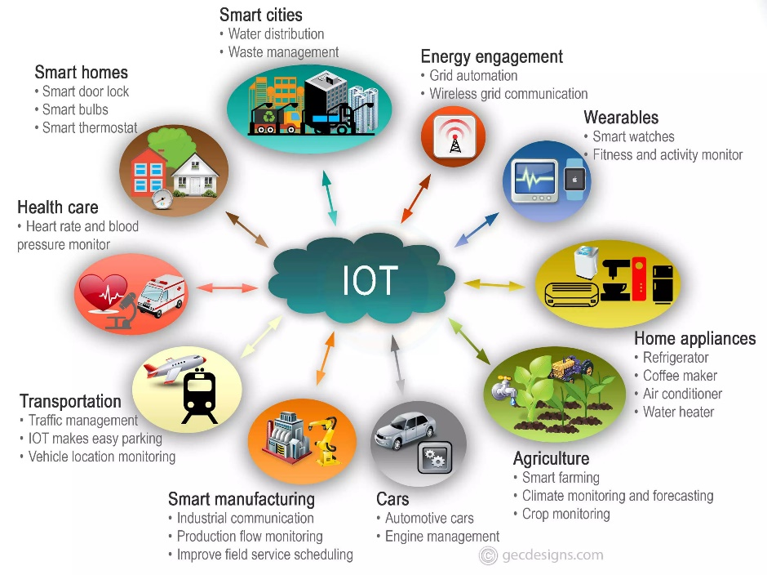

Figure 1.1: The functions of Internet of Things.

A building automation system is a system that employs interconnected devices to provide remote monitoring, control, and management of domestic appliances. Lighting, heating, ventilation, air conditioning, and security are examples of systems. It gives users protection, comfort, and energy efficiency by allowing them to control and manage smart appliances from their smartphone, tablet, computer, or web browser. A smart building, as part of the Internet of Things (IoTs), frequently collaborates, sharing consumer data and automating actions based on the owner's preferences.

This project creates a smart area that can be controlled and monitored using the Raspberry Pi, a small computer. The Raspberry Pi will serve as a microcontroller with connectivity capabilities. To allow this system to function, electrical appliances such as fans, lamps, and air conditioners are linked to the relay as project outputs. This is due to the higher power requirements of these products. The goal of this project is to create a Rental Smart Office Home Office that can be operated using Google Assistant and an Android phone. This system may also be monitored through a web page and an Android-based smartphone. The building control panel is displayed to the user using a website server that runs on Apache and is equipped with PHP and MySQL.

The key features of the system include an auto check in and check out system, monitoring, and controlling electrical appliances that is present in the building. The system implements the use of home automation such as voice recognition and mobile applications to control the appliances. For controlling electrical appliances, the Google Assistant will be used to receive and issue commands to the microcontroller. Concept of home automation is executed, where the appliances in the buildings relate to each other over the Internet to allow human-machine interactions. Raspberry is mainly being used in projects because of its functionality which can be used as a server. The project also implements the use of temperature sensor. The sensor will be used to inform the user of the current room temperature. It will be displayed on a screen in the building as well as through the mobile application.

The Google Assistant application is enabled by giving or using a command to the electrical appliances for the task at hand. The Adafruit.io server is a web-based application for controlling Arduino, Raspberry Pi, NodeMCU, and other boards. As a result, the If This Then That (IFTTT) application is a tool for automating everything from favourite apps and websites to connected accessories and smart gadgets.

This project demonstrates the design and implementation of a building automation system that allows electrical appliances to be controlled and monitored remotely. The project can also control and manage electrical appliances using Google Assistant technologies and the NodeMCU microcontroller. The NodeMCU will send the command to the electrical appliances after the users gives it to Google Assistant. This technology can make life easier for people by reducing the amount of movement required to control and manage electrical appliances.

Based on the project reviewed, a few enhancements have been made to be applied to the proposed project. The project will be aimed to be used in the smart Small Office Home Office (SOHO). It will be focussing on controlling the electrical appliances via cloud based or wireless. Followed by that is the counter and payment which are related to each other. The ease of use itself is also an important part of the system.

* 1. Objectives

The objectives of this project are:

1. Autonomous remote control electrical appliances.
   1. Controlling electrical appliances via cloud-based or wireless.

A mobile application and a smart home assistant will act as the controller.

Users can control the electrical appliances via these two methods. These control features can only be used by verified users. Before accessing the control functions, the user or renter must first log in.

1. Energy consumption calculations.
   1. The system will be embedded with a counter to measure the usage of the electricity to calculate the payment. The time or counter in the microcontroller will start when the tenant check in into the SOHO. Once the tenant checks out, the counter will stop, and the microcontroller will start calculating the electricity usage.

1.3 Problem Statements

During the coronavirus epidemic of the previous two years, most individuals spent more time at home than ever before. Switching to a hybrid or entirely remote work schedule saves money on petrol and reduces travel time, but it can also lead to higher home expenditures. The cost of utilities might double or even treble depending on how much time you spend at the office or away from home. While working remotely, the light state is turned on for most of the day, everyone will be connected to the internet, and the air conditioning will be on. All of this adds up to increased costs. It is unusual to return home to a room that is either too hot or too cold. It would naturally lower the traditional thermostat low or off when leaving home (assuming no one is left at home) to save on heating costs and adjust accordingly upon returning. Walking into a cold, uninviting place, on the other hand, can be aggravating.

* 1. Scope and Limitations

The project is targeted to be used in the rental office. Like other rental buildings such as Airbnb and hotel. The project will be focussing on office or working space instead of those homestays for vacation rentals.

Only a few factors of home security, safety, control, and comfort were considered during the project's development. Unwanted events, such as unlawful entrance and burglary, require an important level of security. As a result, these three elements will be the primary focus.

This project can be a benefit to the users as it can help them to live comfortable and safe. Like any project being developed, there are some limitations that unable to be avoided but can be addressed in the future. This project will be using an Android-based smartphone, tablet and laptop based to control the device and monitor the home. Without this main component, the project cannot be utilized.

Henceforth, the project must have a steady internet connection so it can be connected to the interface. As the project is mainly using a Wi-Fi connection, the user needs to have Wi-Fi setup to connect with the interface. Thus, this can be a limitation to the users as some of the user might not have a steady Wi-Fi connection.

Besides, this project is not so robust against rouge smart devices for instance intruders or hackers. As this project is developed to focus more on the basic safety, control, and security inside and outside of the home but not on the security of the interface. Hence, this limitation can cause many disadvantages as the interface is susceptible to external attacks.

Over time, smart home systems will require upkeep, because smart systems are highly fragile, you must guarantee that adequate maintenance is carried out. Smart systems are electrical technologies that can fail if the installation was not done correctly or if a minute short circuit occurs between two tiny electronic components, such as resistors for OP AMPS. In such circumstances, the system will need to be repaired or replaced, which would cost a lot of money. That is why regular maintenance is necessary.

**CHAPTER 2: LITERATURE REVIEW**

2.1 Introduction

The history of smart buildings and the sub-systems that will be integrated will be outlined and explored in detail in this chapter to help the reader comprehend the project. This chapter will detail the previous and current projects so that the reader may observe how the smart home system has progressed. Some related works will be given as well, to inform the reader about prior and recent advancements in smart building systems. Aside from that, the literature study will be discussed in this chapter, which contains information obtained to gain knowledge and ideas for completing the project. Several sources have been used as resources, including thesis, journals, and websites. It includes the project's functioning, as well as the necessary hardware and software.

Automation is increasing day by day like a competition between players on a field. When most people think about home automation, they imagine a smart home with one remote control for all their appliances, rice cooking automatically, air conditioning beginning automatically, bath water heating automatically, and window shading automatically at night. In some ways, home automation is synonymous with a smart house. They both encourage smart living and makes our life easier and more efficient. The project aims to develop a smart office or working space automation system which is designed using IoT. With the help of this system, the electrical appliances such as lights, fans and air conditioner can be controlled and observed through a website very easily.

The project aims to embed the office or working space with smart home system. The proposed system focuses on controlling the electrical appliances via cloud based or wireless. Followed by that is the counter and payment which are related to each other. The system will be embedded with a counter to measure the usage of the electricity to calculate the payment. Lastly, is the user friendliness of the system. The ease of use itself would be an objective of the system.

The project reviews will include publications, journals, and past research in the same fields that are relevant to the project's goal and objectives. The different publishing years of the projects analysed allow us to assess how far the project has progressed and whether any new technology has been incorporated to projects with comparable goals and objectives. The majority of the project's functionality is designed to assist handicapped and elderly individuals in controlling home appliances.

The project that is going to be proposed will be aimed to develop an automation Small Office Home Office (SOHO) system with rental functionality such as a counter and timer to calculate the electricity usage as well as controlling and monitoring the domestic appliances. These appliances are fans, lamps and air conditioners. FONT COLOUR?

2.2 Overview of the Previous Project

2.2.1 IoT-Based of Automatic Electrical Appliances for Smart Home.

The goal of the project is to combine light, curtain, and air conditioner remotes into a long-distance IP-based system that implements a semi-automatic system for smart building use. Light and room temperature can be controlled more easily, and the room's electrical energy usage may be reduced.

A set of IR LED Transmitters regulates the air conditioner's temperature while other sensors monitor the room's temperature for temperature adjustment. A Smartphone is used to manage and monitor the system through the internet network.

Figure 2.2.1 shows the project system architecture. The performance of the suggested system is determined by the delay time response parameter. The Raspberry Pi and the Smartphone are both connected to the same Internet Service Provider for testing. For each controlled device, data retrieval is performed ten times. (Intan Sari Areni, 2020)

Figure 2.2.1: Project A proposed system architecture.

2.2.2 Control Home Appliances Through Internet of Things to Assist Elderly in Their Daily Routine.

The main objective of this study was to develop an Internet of Things (IoT) based pulse sensor solution to undertake the challenges that elderly Malaysians face at home, such as turning on and off the home appliances so that they can live independently without assistance from a third-person even with minimum movement.

Figure 2.2.2 shows the project system design. The system design lays out the many components and subsystems that form the fully working system. This smart home appliance control unit has a total of two major subsystems. The system is made up of two microcontrollers: microcontroller A and microcontroller B.

Figure 2.2.2: Project B system design.

By collecting sensor data, the sensors give input to the system. Microcontrollers connect with one another using Wi-Fi, allowing them to share data and orders. Finally, the microcontrollers regulate the output of the household appliances. (Karsten Cheng Kai Phua*, 2021)

2.2.3 Smart Home Automation using IoT.

Smart Building not only refers to reduce human efforts but also energy efficiency and time saving. In this ASP.NET is used in which appliances are connected to sensors and sensors give a status of appliances to the web. Here electric appliances are operated by the website. The main objective of home automation and security is to help handicapped and aged people that will enable them to control home appliances and alert them in critical situations. Figure 2.2.3 shows the block diagram of the project.

Figure 2.2.3: Block diagram of smart building architecture.

The PCB, humidity sensor, and Arduino controller are the three components of the system hardware. The PCB has a relay, LPT port, transistor, and diode resister. The fan and the light are the two devices that are linked to the PCB. Arduino is linked to a humidity sensor. It will also detect humidity and temperature. The PC is linked to the Arduino and PCB. Through the PC, Arduino and PCB will communicate with one another. (Dhakad Kunal, 2017)

2.2.4 Google Assistant Controlled Home Automation.

The goal of this project is to use speech to control home electronics. The Google Assistant is used in this project and requires voice instructions. The Adafruit account, which is a cloud-based free IoT web server for creating virtual switches, is linked to the IFTTT website, which is used to generate if-else conditional statements. The IFTTT website has been updated to include voice commands for Google Assistant.

Figure 2.2.4 shows the block diagram of the project. Home appliances like as bulbs, fans, and motors may be controlled according to the user's commands to the Google assistant in this home automation. The Google Assistant commands are deciphered and delivered to the microcontroller, which controls the relays linked to it. According to the user's request to the Google Assistant, the device linked to the relevant relay can be switched on or off. (Mr. Kalyan Chenumalla, 2019)

Figure 2.2.4: Block diagram of Google assistant-controlled home automation.

2.2.5 Smart Home Automation and Energy Management.

As the home automation system is a model in this project, it consists of several sensors such as gas, motion, IR, keypad lock, and Peltier a thermoelectric module. The Arduino connects to the internet through Wi-Fi at first, then begins reading sensor parameters after the connection is established. As soon as the relevant sensors' threshold levels are established. Sensor data is delivered to a web server and then stored in the cloud. If the sensor parameter is more than the threshold level, the data may be evaluated at any time. If the sensor parameter is greater than the threshold level, the appropriate actuation is performed.

Figure 2.2.5: Block diagram of home automation module.

Figure 2.2.5 shows the block diagram of the home automation module. The analogue sensors are used in this project. Arduino board will read the signals. To read signals, the Arduino board contains 6 analogue pins and 13 digital pins. The appliances are also linked to digital pins on the Arduino board. To turn on and off the appliances, the IoT is linked to an Arduino board. The energy meter is also connected to an Arduino board and an IoT module, as well as a GSM module, which reads the units and sends a message to the consumer and service provider. (HARKARE, 2018)

2.2.6 Wireless Home Automation using IoT.

A web page with a user configurable front end will be used to regulate and monitor the load or electrical appliances in this project. The user can transmit commands to the Wi-Fi module by using the assigned IP address. The Wi-Fi module is set up to connect to the internet using any nearby wireless modem. A software within a Wi-Fi module executes the commands received by the Wi-Fi module. The Wi-Fi module is connected to a TRIAC and an optocoupler, which allows the loads to be switched on and off using instructions. On the web page, the load status (ON or OFF) will be shown. (Agrwal)

Figure 2.2.6 below shows the block diagram of the project. The home automation using IOT project consists of various blocks such as power supply, Optocoupler, Wi-Fi module, TRIAC, voltage regulator, SMPS (Switch Mode Power Supply) and load.

Figure 2.2.6: Home automation using IoT block diagram.

2.2.7 Home Automation Based on IoT.

The strength of this project is the ability to use a smartphone to manage household devices such as lights and doors. The system is linked to NODEMCU-enabled household appliances. A relay, servomotor, bulb holder, and bulb are among the hardware components used in this project. In comparison to another project that uses a tablet, laptop, or other device to issue commands, this project uses a smartphone, which is far handier for consumers.

The smart house is environmentally friendly, and it assures not wasting electricity. Furthermore, the smart house can deter burglars by sounding an alarm or sending a warning to us through a smartphone application. Figure 2.2.7 shows the project block diagram.

Figure 2.2.7: Home automation based on IoT block diagram.

This project differs from others in that it uses NODEMCU instead of a Wi-Fi module, while the most of them utilise Arduino, Bluetooth, ZigBee, and GSM. The similarity is that we are utilising IOT as a platform to control the equipment at home, and our gadgets must first be linked to the internet before giving commands through a mobile application. (Aman, 2019)

2.2.8 IoT Based Home Automation using Arduino.

The goal of this project is to create a low-cost, high-efficiency smart home system. The hardware interface module and the software communication module are the two key modules in this system. The Arduino UNO microcontroller, which also serves as a tiny web server and interfaces for all of the hardware components, is at the core of this system. The microcontroller is responsible for all communication and control in this system.

Environmental monitoring employing temperature, humidity, gas, and smoke sensors is one of the features of the smart home system. It also has switching capabilities for controlling lighting, fans, and air conditioners, as well as other home appliances that are connected to the relay system. This system also has an intrusion detection function that uses a motion sensor, and all of this can be controlled with an Android smartphone app or a web browser. Figure 2.2.8 shows the overview of the system.

Figure 2.2.8: Overview of the system.

Arduino can perceive its environment by accepting input signals from several sensors and may influence it using actuators. An analogue temperature sensor is a chip that measures the temperature of the surrounding environment.

The DHT11 is a simple digital temperature and humidity sensor with a modest price tag. It measures the ambient air with a capacitive humidity sensor and a thermistor and outputs a digital signal on the data pin (no analogue input pins needed). (G.Mahalakshmi, 2017)

2.2.9 IoT Based Smart Home Automation System.

The goal of this project is to employ motion detection to turn lights on and off, a MQ2 sensor to detect gas, machine learning to recognise facial expressions, a motor to open and close the façade, a motor to rotate the room, and finally the website "ThingsBoard" to gather all of the data in one place. The major purpose of this project is to combine complete security with home innovation.

Figure 2.2.9 shows the project system architecture. The project outlines a strategy for creating a smart, low-cost home automation system based on IoT. All household appliances and electrical machinery may be readily managed and inspected with this system, which can be accessed via a website. This technique may also be used to monitor a home's metering approach. This project also attempts to operate and monitor the system utilising an embedded micro-web server with IP connectivity for remote access and control of devices and appliances using an Android-based Smartphone app. (Aakriti Tyagi, 2020)

Figure 2.2.9: System architecture.

(Figure 2.2.9 Not clear)

2.3 Review of Potential Solution Instrument.

2.3.1 Hardware.

1. Raspberry Pi.

According to this website (What is a Raspberry Pi?, n.d.), Raspberry Pi is a minicomputer the size of a credit card that was created in the United Kingdom to control electrical gadgets. People use Raspberry Pi across the world to study programming, construct hardware projects, build smart homes, and even utilise them in industrial applications. The Raspberry Pi is a low-cost computer that runs Linux and has a set of GPIO pins for controlling electronic devices for physical computing and exploring the Internet of Things (IoT).

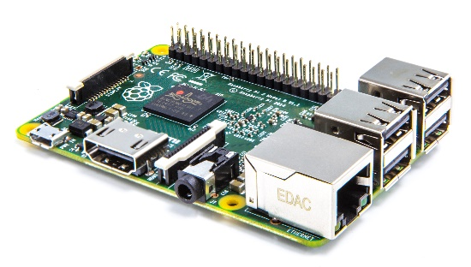

Figure 2.3.1.1: Raspberry Pi.

1. Wi-Fi ESP8266.

The ESP8266Wi-Fi Module is a self-contained SOC with an integrated TCP/IP protocol stack that can provide access to your Wi-Fi network to any microcontroller. The ESP2866 may either host an application or offload all Wi-Fi networking activities to a different application processor. (techZero, 2018)

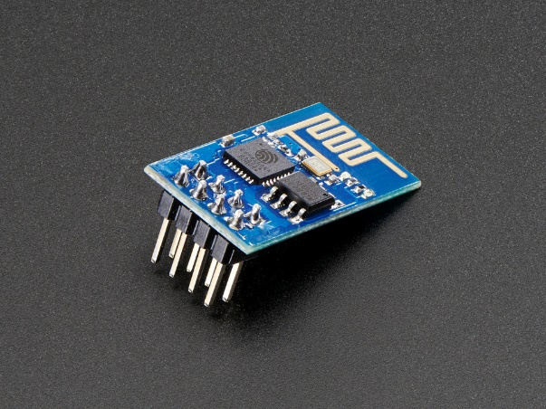

Figure 2.3.1.2: Wi-Fi ESP2866.

1. NodeMCU.

NodeMCU is an IoT platform open source. It includes firmware running on Espressif Systems ' ESP8266 Wi-Fi SoC and hardware based on theESP-12 module. By default, the term "NodeMCU" refers to the firmware as opposed to the development kits. The firmware uses the language of Lua scripting. It is based on the project Lua and is based on the ESP8266 Espressif Non-OS SDK. (components101, 2020)

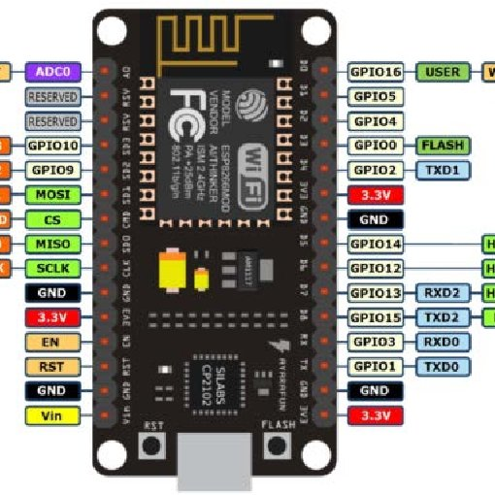

Figure 2.3.1.3: NodeMCU architecture.

1. DHT22 Temperature Sensor.

The DHT-22 is a sensor that monitors relative humidity and temperature and delivers a digital output that is calibrated. It is a low-cost sensor that's almost identical to the DHT11, except it monitors temperature and humidity with more precision and a larger range. (marco, 2022)

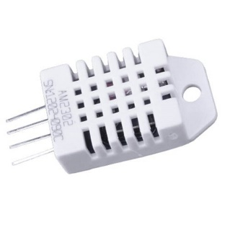

Figure 2.3.1.4: DHT22 Temperature sensor module.

1. Relay Board.

A relay is a switch that is operated electrically. Many relays use an electromagnet to operate a switch mechanically, but other operating principles such as solid-state relays are also used. Relay is used where a circuit must be controlled by a separate low-power signal or where one signal must be used to control several circuits. A type of relay is capable of handling the high power required to control an electronic motor or other loads directly and is called a contactor.

A solid-state relay controls the power circuit without moving parts, rather than using a semiconductor device to switch. Relay is calibrated is operating the characteristics and sometimes multiple operating coils are used to protect electrical circuits against overload or faults; these functions are performed by digital instruments and still is called "protective relay" in the modern electrical power systems. (OurPCB, n.d.)

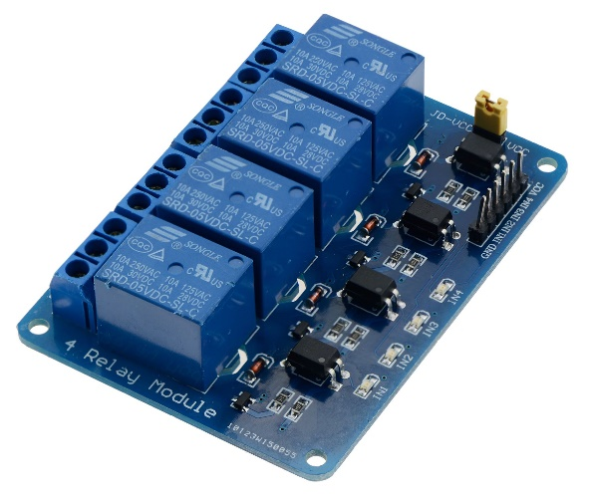

Figure 2.3.1.5: Relay board.

1. Google Nest Mini.

Google Nest Mini is the most affordable Google Assistant smart speaker. It is designed to deliver improved sound quality from previous generations. It promises faster Google Assistant responses and more sensitive voice recognition.

The Google Nest Mini will be connected to the Raspberry Pi and the IFTTT (If This Then That) which is a free web-based service to create chains of simple condition statements. These conditions will be the voice commands associated with the Google home assistant. (Tolcheva, 2021)

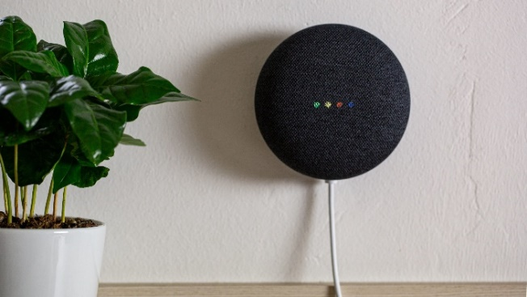

Figure 2.3.1.6: Google Nest Mini.

1. OLED Module Display.

This OLED display was made exclusively for use with the Raspberry Pi. They are available in various sizes, but common sizes include 128×32 and 128×64 pixels. This display will be used to display the room temperature. (Pounder, 2021)

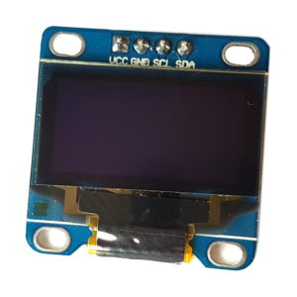

Figure 2.3.1.7: OLED Module Display.

2.3.2 Software.

1. Firebase Database.

Based on (javaTpoint, n.d.) state that the Firebase Realtime Database is a cloud hosted database and a NoSQL database from which it can store and sync the data between the users in real-time. It is a big JSON object which the developers can manage in real-time. By using a single API, the Firebase database provides the application with the current value of the data and updates to that data. Real-time syncing makes it easy for the users to access their data from any device, be it web or mobile. This database is used to store data from the Raspberry Pi, as well as instructions from mobile apps and Google Assistant.

Figure 2.3.2.1: Firebase Realtime Database.

1. Arduino IDE.

The software for Arduino is called Arduino IDE (Integrated Development Environment). It's a text editor with a variety of capabilities, like a notepad. It's used to write code, compile it to see if there are any issues, and then upload the code to the Arduino. It is a cross-platform application that works with all operating systems, including Windows, Linux, and macOS. (Botsolvers, n.d.)

Figure 2.3.2.2: Arduino IDE.

1. If This, Then That (IFTTT) Application.

IFTTT derives its name from the conditional programming statement' If This, Then That’. IFTTT is both applied and used in a website and a mobile app that was launched in 2010 with the slogan, 'Putting the Internet to work for you.' The idea is to use IFTTT to automate everything from your favourite apps and websites to accessories and smart devices that are enabled by the application. (A.Martin, 2020)

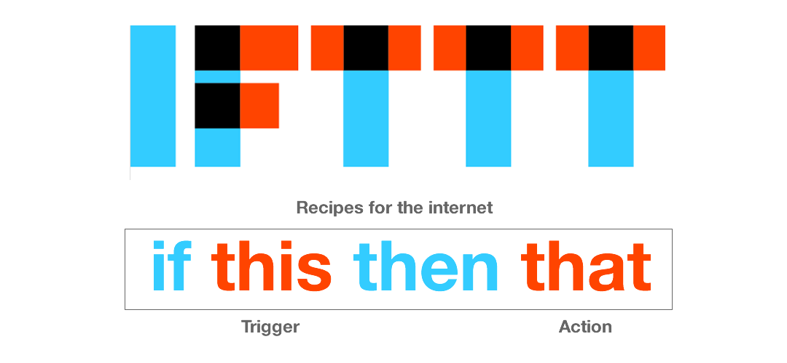

Figure 2.3.2.3: IFTTT application.

1. Google Assistant.

The Google Assistant is a software that allows users to directly control all the applications in their device. It allows users to use voice commands to control and command most of the apps on their devices. This makes people more comfortable as they only have to command the thorough voice command of the google assistant. (Fedewa, 2021)

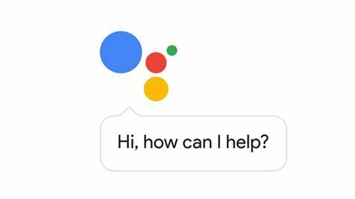

Figure 2.3.2.4: Google Assistant application.

2.4 Systematic Review.

Table 1: Comparison of Previous Project and Proposed Project (If you are going to do hardbound copy, be careful with the margin)

|  |  |  |  |  |  |  |  |  |  |  |
| --- | --- | --- | --- | --- | --- | --- | --- | --- | --- | --- |
| ***PROJECT TITLE*** | ***IoT-Based of Automatic Electrical Appliance for Smart Home*** | ***Control Home Appliances Through Internet of Things*** | ***Smart Home Automation using IOT*** | ***Google Assistant Controlled Home Automation*** | ***IoT Based Smart Home Automation System*** | ***Smart Home Automation and Energy Management*** | ***Wireless Home Automation using IOT*** | ***Home Automation Based on IOT*** | ***IOT Based Home Automation Using Arduino*** | ***I-Working Space with Electrical Appliances Controller*** |
| ***YEAR*** | 2020 | 2021 | 2017 | 2019 | 2020 | 15-Aug-18 | - | Dec-19 | Aug-17 | 2022 |
| ***AUTHORS*** | Intan Sari Areni, Ahmad Waridi | Karsten Cheng Kai Phua*, | Dhakad Kunal, Dhake Tushar | Mr. Kalyan Chenumalla,  Mr. Srikanth Gottam | Aakriti Tyagi, Smita Deshmukh | IMAD ANWAR HARKARE | Tarun Agrwal | Nur Amalina Binti Kamarul Aman | G. Mahalakshmi, M. Vigneshwaran | Anuar Bin Rozman |
| ***FUNCTIONAL*** | Controls lights, temperature of air conditioner. | Controlling home appliances using pulse sensor. | Control and alert users when in critical situations. | Controlling home appliances using voice command from Google Assistant. | Control home automation using sensor and facial recognition. | Controlling home appliances. | IOT based home automation over the cloud. | Control lamp and door at home using smartphone. | Control home appliances for comfortability. | Control appliances via cloud based or wireless.  Counter as payment. |
| ***HARDWARE*** | Raspberry Pi 3, Relay SPDT 12V DC, L2982 Driver, Motor Stepper Nema 17, and IR LED Transmitter. | NodeMCU, LED, Temperature Sensor, Pulse Sensor, and Fan. | Arduino ATmega2560, PCB, Humidity sensor, Relay, LPT port, Transistor, and Diode resistor. | NodeMCU 32-bit, ESP8266, Relay module, 15W Bulb, and 9V DC Fan. | Raspberry Pi, Motion sensor, Gas sensor, Camera, Relay, Stepper motor, and Motor driver. | Relays, IC Sockets, Arduino Mega, Connectors, PCB, Transformer, Wi-Fi receiver, and LCD. | Wi-Fi module, Opto-coupler, TRIAC, Resistors, Capacitors, Diode, and Regulator. | Raspberry Pi, NodeMCU,  Relay, Servomotor, Step down transformer, and Adapter. | Arduino UNO, Wi-Fi Module, PIR sensor, Gas Sensor, and MQ6 Sensor. | Raspberry Pi, ESP8266, Relay Module, DHT22, Google Nest Mini, NodeMCU, and 7-inch LCD Panel. |
| ***SOFTWARE*** | MIT App Inventor 2 | Blynk | ASP.NET | Adafruit IO, IFTTT Service, and Arduino IDE | FisherFace. | Arduino IDE | Command Prompt | Telegram Apps | Eclipse IDE | Firebase Realtime Database, and Arduino IDE. |
| ***DATABASE*** | The Local Host NGROK. | Firebase Database. | ASP.NET. | Adafruit IO, and IFTT Service. | ThingsBoard. | Web Server Database. | Web Server Database. | Telegram Apps as cloud. | Eclipse Platform Telnet.  Database management system. | Firebase Database. |

2.5 Conclusion.

In conclusion, (Aakriti Tyagi, 2020), (Agrwal), (Dhakad Kunal, 2017), (G.Mahalakshmi, 2017), (Gupta, 2018), (HARKARE, 2018), (Intan Sari Areni, 2020), (Karsten Cheng Kai Phua*, 2021), (Mr. Kalyan Chenumalla, 2019) agree that energy may be saved by implementing smart and automation systems into the building. The component chosen for the proposed project is the most functional. This is to ensure that the goals are attainable.

Different method has been shown in the reviewed projects. Some solely use Raspberry Pi (Intan Sari Areni, 2020) and (Aakriti Tyagi, 2020) as the project microcontroller but based on (Aman, 2019), the best alternative appears to be splitting the control system into two parts: Raspberry Pi and NodeMCU. The Raspberry Pi serves as an information receiver or database link, while the NodeMCU collects sensor data, processes it into information, and then sends it to the Raspberry Pi. For backend, Python is used along with the flask Python library to make the Raspberry Pi act as a server. In this project, Google Assistant will be linked to IFTTT (If This Then That), to create chains of simple conditional statements which can be referred to as applets. It is used to connect the Raspberry Pi to the Google Assistant.

The suggested project will be outfitted with sensors and hardware to meet the project's objectives. Implementing smart control to the electrical appliances is extremely complicated. Most of the projects examined use prototypes rather than genuine testing. When using the system in a real building, several factors must be addressed, such as the sensor's effective range and effective distance for voice instructions. The comparison of current initiatives will assist the planned project in meeting its goals. To summarize, the evaluated project employs the same principle for project idea execution, but on a smaller scale.

**CHAPTER 3: METHODOLOGY**

3.1 Introduction.

In order to build this project, the methodology is essential since each phase is divided into two parts: hardware and software development. The overall process block diagram will be presented in this chapter. All relevant processes have been discussed in depth to aid comprehension. As a result, the focus of this chapter is on the method used by all of the project's components.

The methods used to perform the study are the subject of this chapter. The first section of this chapter explains how to gather data and obtain the information needed to complete this project. The following section contains a list of the components and software that were used. Furthermore, it goes into the methods for how the system works. The project flow and how the project operates are detailed in the next section. This chapter covers the activities involved in completing the project. This chapter also includes cost estimates for all the project's components. Finally, the final section, discusses the overview of this project.

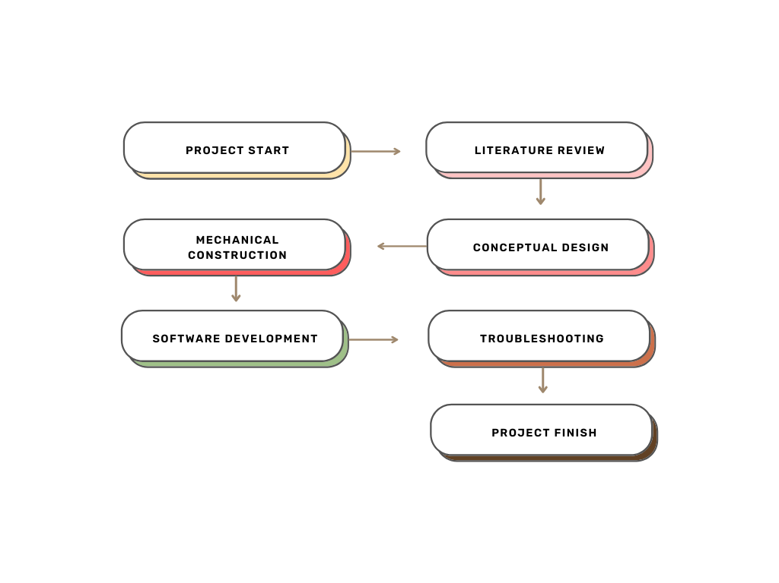

Figure 3.1: Project process flow.

3.2 Methodology Choice and Justification.

The methodology that is used in developing this project is Prototype model. The prototyping model is a system development process in which a prototype is built, tested, and then recreated as needed until an acceptable result is achieved from which to develop the entire system or product. The design is then generated based on the requirements, and the prototype for a specific design is modelled and provided to the users; finally, the relevant changes are made based on the user feedback.

3.2.1 Prototype Model.

Figure 3.2.1 shows the phases of the prototyping model. There are four phases in this model which are communication, design, modelling, and deployment. During the communication phase, the developer and client set up the meeting to discuss the objectives that need to be achieved. In designing phase, design of the project is used to construct the prototype. It includes the important aspects of hardware and software. Next, the modelling phase provides a better idea of the project’s requirements. Before deployment phase, the client needs to evaluate the system and if they are not satisfied, the system needs to be refined according to their requirements. This process goes on until both sides has reach an agreement and the client’s satisfaction accomplished. (Pedamkar)

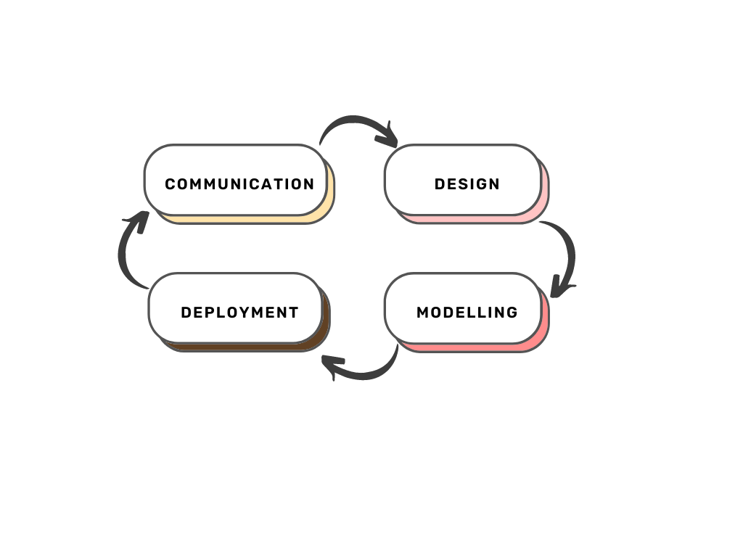

Figure 3.2.1: Graphical illustration of prototype model.

3.2.2 Methodology Justification.

The prototype model has been selected because it is very suitable for the project since it is involving the developer and the client which is in this case the client is Farbeat Technologies Sdn. Bhd. There are several other reasons this type of methodology has been chosen.

To begin with, this model has increased the user's and developer's involvement in the product development process. Following that, the user may see what has been done and what remains to be done in terms of the need at implementation time. This enables the requirement to be changed at an early stage if necessary. It also assists in receiving user feedback and making modifications as needed. Finally, the missing, confusing, and challenging features are easily identified in this model.

This model also has some drawbacks or concerns. One of the issues is that it increases the system's complexity and timelines. It is also not possible to develop the new system using the existing prototype. Aside from that, creating a system prototype takes a lot of time and effort. Finally, if the users or clients are unhappy with it, it can be rejected.

3.3 Phases in Prototype Methodology.

Each phase of the prototype process will be described in detail in this section. Each phase plays a significant part in the project development of the proposed system in order to successfully construct the system. These four phases are communication phase, designing phase, modelling phase and deployment phase.

3.3.1 Communication Phase.

In this phase, meeting with the client has been done almost three times. During the first meeting, the project is given by one of the lecturers in UniKL instead of personally meeting with the client. During this time, a discussion with the supervisor had been done to grasp a better understanding of the general layout of the project. The second meeting was held to let the client brief in detail on the project’s objectives and their needs. The second meeting was done with a representative of the company, not with the staff who is related to the project. But the general idea of the project is well understood. The last meeting with the client during FYP 1 period was held with the CEO of the company itself. This is when the client added a few more requirements into the system.

During this phase, the developer planning also has been discussed with the client. To make sure the client understands that the developer needs to focus on the research section for the first Final Year Project part. Figures 3.3.1.1 and 3.3.1.2 show the overall planning for both FYP sessions.

|  |  |  |  |  |  |  |  |  |  |  |  |  |  |  |
| --- | --- | --- | --- | --- | --- | --- | --- | --- | --- | --- | --- | --- | --- | --- |
| Week/Task | 1 | 2 | 3 | 4 | 5 | 6 | 7 | 8 | 9 | 10 | 11 | 12 | 13 | 14 |
| FYP 1 Presentation |  |  |  |  |  |  |  |  |  |  |  |  |  |  |
| FYP Proposal |  |  |  |  |  |  |  |  |  |  |  |  |  |  |
| Chapter 3 |  |  |  |  |  |  |  |  |  |  |  |  |  |  |
| Chapter 2 |  |  |  |  |  |  |  |  |  |  |  |  |  |  |
| Chapter 1 |  |  |  |  |  |  |  |  |  |  |  |  |  |  |
| Article Review |  |  |  |  |  |  |  |  |  |  |  |  |  |  |
| Title Defence |  |  |  |  |  |  |  |  |  |  |  |  |  |  |
| Title Submission |  |  |  |  |  |  |  |  |  |  |  |  |  |  |

Figure 3.3.1.1: Gantt chart for FYP 1.

|  |  |  |  |  |  |  |  |  |  |  |  |  |  |  |
| --- | --- | --- | --- | --- | --- | --- | --- | --- | --- | --- | --- | --- | --- | --- |
| Week/Task | 1 | 2 | 3 | 4 | 5 | 6 | 7 | 8 | 9 | 10 | 11 | 12 | 13 | 14 |
| Documentation |  |  |  |  |  |  |  |  |  |  |  |  |  |  |
| Presentation |  |  |  |  |  |  |  |  |  |  |  |  |  |  |
| Chapter 5 |  |  |  |  |  |  |  |  |  |  |  |  |  |  |
| Chapter 4 |  |  |  |  |  |  |  |  |  |  |  |  |  |  |

Figure 3.3.1.2: Gantt chart for FYP 2.

3.3.2 Design Phase.

In this phase, a quick plan of the initial prototype is made. Multiple brainstorming session has been done to decide on components especially on the microcontroller. There are several parts in the system. The first section discusses the system architectural design, which shows the total system. Starting from the user interaction or input until the output which is the use of domestic appliances such as fans, lamps, and air conditioners. Next, the use of the block diagram. All the requirements of the system will be stated clearly. The important parts' functionality has also been discussed.

The flow chart has been created to show how the system works. It will also show the functionality of the system based on different situations. Figure 3.3.2.1 shows the block diagram of the project.

Figure 3.3.2.1: System block diagram.

The block diagram above shows the general idea of how the system will work. Starting from the user input which is coming from the Google Assistant and mobile application. Then the commands are sent to the microcontroller through Wi-Fi. Then, activating the specified relay to turn on the electrical appliances. Then the status of the electrical appliance will be sent to the website and mobile application for monitoring. The temperature sensor will read the current room temperature and the data will be sent to display on the monitoring devices.

Details on the flow of the system is shown in Figure 3.3.2.2. The user needs to start the system. After that, the user must make sure that the system is connected to the Internet. The system can be controlled either with a smartphone or Google Assistant. For mobile applications, the button needs to be pressed to turn on or off the significant electrical appliances while for Google Assistant, the IFTTT application will then analyse the command according to the set of commands. The temperature sensor will read the current room temperature for monitoring purposes. Lastly, all the data will be sent back to the monitoring system.

Figure 3.3.2.2 Project flowchart.

* Hardware Requirements.

Table 2 displays the hardware that will be used to meet the project's minimum requirements.

Table 2: Hardware Requirements.

|  |  |  |
| --- | --- | --- |
| ***No.*** | ***Hardware*** | ***Functionality*** |
| 1. | Raspberry Pi | It is a low cost mini computer. It is also a low-energy consumption with good performance, passive cooling, and its extensibility. It can control multiple components at the same time compared to Arduino. |
| 2. | NodeMCU ESP8266 | NodeMCU is a platform for open source  IoT. It includes firmware running on  Espressif Systems ' ESP8266 Wi-Fi SoC  and ESP-12 based hardware. |
| 3. | Relay Board | Relays are switches that electromechanically or electronically open and close circuits. By opening and closing contacts in another circuit, relays control one electrical circuit. |
| 4. | DHT22 Temperature Sensor | A digital temperature and humidity sensor. It uses a capacitive humidity sensor and a thermistor to measure the surrounding air and spits out a digital signal on the data pin. |
| 5. | Google Nest Mini | Uses a high-quality microphone system to recognize the commands and do as instructed. It can also play music with high quality. A go to solution for having a digital assistant ready at a moment’s notice. |
| 6. | OLED Display Module | To connect to the Raspberry Pi purposedly to display the room temperature read by the DHT22. |
| 7. | Raspberry Pi Camera | Use to scan the QR code from the user. The electrical system in the building will turn on if the QR code scanned is successful. It is also used to determine user check in and check out of the building to calculate the rent. |

* Software Requirements.

Table 3 shows the list of software.

Table 3: Software requirements.

|  |  |  |
| --- | --- | --- |
| ***No.*** | ***Software*** | ***Functionality*** |
| 1. | Firebase Database | This will act as a database server to store user data and status of the electrical appliances in the building. |
| 2. | Arduino IDE | To program the NodeMCU. |
| 3. | If This, Then That Application (IFTTT) | To customize and control the integrations with filter commands or code, multiple actions, and queries. |
| 4. | Google Assistant Application | To control all the application in the device and allow user to use voice commands. User can control several things if the command has been set in the IFTTT application. This application can be use with the Google Nest Mini is beneficial since it can also play certain notifications. |

3.3.3 Modelling Phase.

During this phase, the prototype of the design discussed will be tested to provide a better idea of the project’s requirements and a better understanding of the project. This will take a lot of time before the real product can be developed. This is to avoid wasting money on unnecessary costs until the client is satisfied with the prototype's results and approves the system's operation.

After purchasing the components and putting them together, the prototype must be put through its tests. During FYP 2, this phase will take place.

3.3.4 Deployment Phase.

Even though this phase is not yet occurred, the general idea of this phase is to let the client evaluates the system. This process will go on until the client is satisfied with the result. If not, further discussion is needed between the developer and the client. Repeating the first phase, the communication phase to improve the understanding of the system. Details on this phase will be explained on FYP 2.

3.4 Budget.

Table 4 below shows the draft of the cost of all the hardware and software. The list of budgets below is not the final budget. A few more parts will be added during the construction of the project on FYP 2. Some of the parts listed are for building a prototype to test the system's functionality.

Table 4: List of budgets.

|  |  |  |  |
| --- | --- | --- | --- |
| ***No.*** | ***Item*** | ***Quantity*** | ***Cost (RM)*** |
| 1. | Raspberry Pi 4 | 1 | RM 300.00 |
| 2. | NodeMCU | 1 | RM 39.00 |
| 3. | Google Nest Mini | 1 | RM 150.00 |
| 4. | DHT22 | 2 | RM 25.00 |
| 5. | Relay Board | 1 | RM 22.90 |
| 6. | Breadboard | 2 | RM 30.00 |
| 7. | OLED Display Module | 1 | RM 14.90 |
| 9. | Jumper Cables | 25 | RM 25.00 |
| 10. | Bulb as lamp | 2 | RM 1.50 |
| 11. | Fan (5V) | 1 | RM 10.00 |
| ***Total*** | | | ***RM 618.30*** |

3.5 Proof of Concept.

The first circuit diagram of the project has been created. The prototype still cannot be assembled because the Raspberry Pi is still out of stock during this time. This circuit diagram is for the prototype, not for the real application. For testing purposes only. Figure 3.5 shows the circuit diagram of the project.

Figure 3.5: Draft of the prototype circuit diagram.

3.6 Conclusion.

In conclusion, this project was conceived as a simulation and modelling. This study is to make the system that uses Google Assistant, mobile application, and Raspberry Pi as microcontroller in the smart building system. This project uses various types of components to stimulate the project, such as Relay board, Pi Camera for QR code scanner and IFTTT application.

To complete this project, one methodology type has been chosen which is the prototype model. There are 4 phases in this model. The first phase is known as the communication phase, the second phase is the design phase, the third phase is the modelling phase and lastly is the deployment phase. All of the phases is related to each other. Also included in this chapter are all the activities performed during the first half of completing this project and the project cost estimation.

# REFERENCES

A.Martin, J. (2020, September 25). *What is IFTTT? How to use If This, Then That services.* Retrieved from COMPUTERWORLD: https://www.computerworld.com/article/3239304/what-is-ifttt-how-to-use-if-this-then-that-services.html

Aakriti Tyagi, S. D. (2020). *IoT Based Smart Home Automation System.* Retrieved from AcademiaEdu: https://www.academia.edu/47402701/IoT_Based_Smart_Home_Automation_System

Agrwal, T. (n.d.). *Wireless Home Automation using IOT.* Retrieved from elprocus: https://www.elprocus.com/wireless-home-automation-using-internet-of-things/#:~:text=Home%20Automation%20using%20IOT%20Project%20Block%20Diagram%20The,load.%20Designing%20DIY%20Blocks%20of%20Home%20Automation%20System

Aman, N. A. (2019, December). *Home Automation Based on IOT.* Retrieved from http://repository.psa.edu.my/bitstream/123456789/2127/1/HOME%20AUTOMATION%20BASED%20ON%20IOT.pdf

Botsolvers. (n.d.). *What is Arduino IDE? And its different functions.* Retrieved from Botsolvers: https://botsolvers.com/what-is-arduino-ide-and-its-different-functions/

components101. (2020, April 22). *NodeMCU ESP8266*. Retrieved from components101: https://components101.com/development-boards/nodemcu-esp8266-pinout-features-and-datasheet

Dhakad Kunal, D. T. (2017, February). *Smart Home Automation using IOT.* Retrieved from https://www.ijarcce.com/upload/2016/february-16/IJARCCE%20131.pdf

Fedewa, J. (2021, January 13). *What Is Google Assistant, and What Can It Do?* Retrieved from How-To Geek: https://www.howtogeek.com/692895/what-is-google-assistant-and-what-can-it-do/

G.Mahalakshmi, M. (2017, August). *IOT Based Home Automation Using Arduino.* Retrieved from ResearchGate: https://www.researchgate.net/publication/321874873_IOT_Based_Home_Automation_Using_Arduino

Gupta, V. (2018, December 26). *DIY Smart Home : Google Home + Raspberry Pi*. Retrieved from Vishal Gupta: http://vishalgupta.me/smart-home/

HARKARE, I. A. (2018, August 15). *Smart Home Automation and Energy Management.* Retrieved from Electronics Lovers: https://www.electronicslovers.com/2018/08/smart-home-automation-and-energy-management-final-year-project-2018.html

how2electronics. (2021, August 3). *Home Automation using Google Firebase & NodeMCU ESP8266*. Retrieved from how2electronics: https://how2electronics.com/home-automation-using-google-firebase-nodemcu-esp8266/

Intan Sari Areni, A. W. (2020, November 10). *IoT-Based of Automatic Electrical Appliance for SmartHome.* Retrieved from https://online-journals.org/index.php/i-jim/article/view/15649/8145

javaTpoint. (n.d.). *Firebase: Realtime Database*. Retrieved from javaTpoint: https://www.javatpoint.com/firebase-realtime-database

jwslcd. (n.d.). *What To Know About a 7 Inch TFT LCD Panel?* Retrieved from jwslcd: https://www.jwslcd.com/what-to-know-about-a-7-inch-tft-lcd-panel.html

Karsten Cheng Kai Phua*, W. W. (2021). *Control Home Appliances Through Internet of Things To Assist Elderly In Their Daily Routine.* Retrieved from https://www.researchgate.net/publication/348744608_Control_Home_Appliances_Through_Internet_of_Things_To_Assist_Elderly_In_Their_Daily_Routine

marco. (2022, February 3). *DHT22 Temperature and Humidity Sensor Interfacing with Pic Microcontroller*. Retrieved from microcontrollerslab: https://microcontrollerslab.com/dht22-temperature-humidity-sensor-interfacing-pic-microcontroller/#:~:text=DHT22%20Introduction.%20The%20DHT-22%20is%20a%20sensor%20which,and%20humidity%20with%20higher%20accuracy%20and%20wider%20range.

Mr. Kalyan Chenumalla, M. S. (2019, November). *Google Assistant Controlled Home Automation.* Retrieved from https://ieee-vecsb.org/wp-content/uploads/sites/45/Google-assistant-controlled-home-automation.pdf

OurPCB. (n.d.). *Relay Module: A Complete Guide*. Retrieved from OurPCB: https://www.ourpcb.com/relay-module.html#:~:text=A%20relay%20module%20is%20an%20array%20of%20one,is%20because%20it%20comes%20with%20a%20few%20advantages.

Pedamkar, P. (n.d.). *Prototype Model.* Retrieved from educba: https://www.educba.com/prototype-model/

Pounder, L. (2021, April 23). *How to Use an OLED Display With Raspberry Pi Pico (Updated).* Retrieved from tom's HARDWARE: https://www.tomshardware.com/how-to/oled-display-raspberry-pi-pico

Price, M. (2022, April 6). *Want to Save on Your Utility Bills? Try These Smart Home Devices*. Retrieved from https://www.cnet.com/home/energy-and-utilities/want-to-save-on-your-utility-bills-try-these-smart-home-devices/

techZero. (2018, July 25). *ESP8266 WiFi Module*. Retrieved from techZeero: https://techzeero.com/sensors-modules/esp8266-wifi-module/

Tolcheva, S. (2021, February 23). *What Is a Google Nest Mini and Who Is It For?* Retrieved from makeusof: https://www.makeuseof.com/what-is-a-google-nest-mini/

*Uni Assignment Centre*. (n.d.). Retrieved from The Introduction To Smart Home Technologies Information Technology Essay: https://www.uniassignment.com/essay-samples/information-technology/the-introduction-to-smart-home-technologies-information-technology-essay.php

*What is a Raspberry Pi?* (n.d.). Retrieved from Raspberry Pi Foundation: https://www.raspberrypi.org/help/what-%20is-a-raspberry-pi/

*What Problem Does Smart Home Automation Solve?* (n.d.). Retrieved from https://geargadgetsandgizmos.com/what-problem-does-smart-home-automation-solve/

**APPENDIX A**

Project Flowchart.

**APPENDIX B**

